LAND USE ASSESMENT GUIDE

# I - CONTEXT

A watershed is an area of land that channels streams and rainfall to a common outlet such as the outflow of a reservoir, mouth of a bay, the ocean, or any point along a stream channel. Delineating, or mapping, watersheds help CRS staff make land management decisions and/or target where to work. Making land management decisions at a watershed level allows the watershed to recharge and facilitates sustainable land management. To be able to make land management decisions at the watershed level, the main step is to do an assessment of the land use land cover. Some countries already have this information available. For projects interested in watershed management, we have made available a suite of functions in Arcgis Pro that provide maps and statistical data on the evolution of changes in land use over periods of their choice.

# II - OBJECTIVE

Land use assesment is important because it will help country programs work towards more sustainable management of watershed resources that affect agriculture, disaster risk reduction, flood/landslide management, and water supply infrastructure.

Now, creating a watershed land use assesment involves several steps that require not only a good understanding of the process but also a good knowledge of Arcgis functions.

To facilitate this task, the GKIM team has created this guide to help you perform the analysis, and to support you during the implementation process.

# III – DATA AND SOFTWARE REQUIREMENTS

Inputs:

1. Data

* Area of interest
* Landsat 8 via [USGS Earth Explorer](http://bit.ly/3oVidOV)2.
* Land Use Land Cover Data from the “Dynamic World V1” on Google earth engine
* Sentinel 2 data
* Rainfall Data from CHRIPS

1. Software : ArcGIS Pro

Additional Data Sources:

* Land Use Land Cover Data from ESRI Land Use Land Cover [Global map](https://www.esri.com/partners/impact-observatory-a2T5x0000084pJXEAY/land-use-land-cover--a2d5x000005juReAAI)

# IV – RUN THE PROCESS

If you are interested in Land Use Assesment for your program or project,

* Fill out an [ICT4D Services Support Request Form](http://bit.ly/2CUNGLZ)1!
* Prepare the input data.
* Check the best period for the analysis with the rainfall data.
* Run the Land use land cover in ArcGIS Pro per period.
* Check the changes per period.
* Compare the results with the NDVI changes per period.
* Design the changes maps.
* Run the statistical analysis in ArcGIS Pro
* Interpret the results.

# V – RESULTS

The results of the analysis gives us details of the periodic change in land use, such as the annual proportion of forest converted to plantation..., as well as periodic maps of the change. All this could be further confirmed by the NDVI change map representing the greenness.

However, these results will need to be verified with field data for better accuracy.

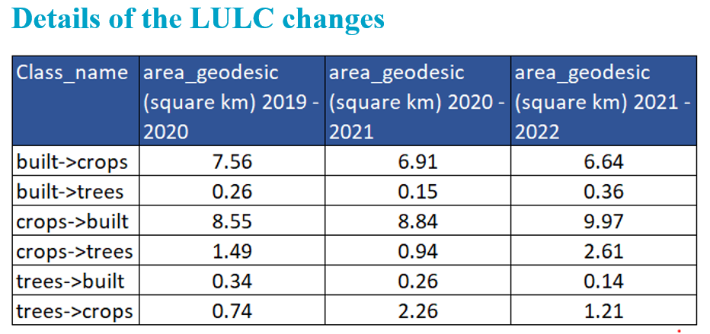

# VI – WHAT TRAINING IS AVAILABLE

To master the raster analysis tools, we suggest you start with basics raster analysis

* [Getting started with imagery and remote sensing](https://www.esri.com/training/catalog/634f16c15030f204ae8e30f4/getting-started-with-imagery-and-remote-sensing/)
* [Imagery in action](https://www.esri.com/training/catalog/6074ab588e68a831e4d8974b/imagery-in-action/)